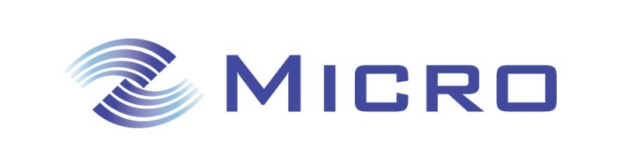
Sales Executive Required to join our Technical Hydraulics Division

Technical Sales Executive Required
We are looking for a Sales Executive to join our technical hydraulics division at our Head Office in City West, Dublin on a permanent full-time basis. We are looking for a flexible, driven and dynamic individual that possesses a blend of sales ability and technical knowledge with a keen interest to learn and grow within the business.
Responsible for existing and new business in Technical Hydraulics, reporting on a weekly basis to the Engineering Manager. Full training will be provided.

Requirements:
- Technical diploma, degree, or 3 years’ experience in the hydraulics industry.
- The ability to work within a team and on own initiative.
- Be sales & customer focused.
- The ability to perform within a busy office environment.
- Full Clean Driving License
- Excellent communication skills
- Computer proficient
Responsibilities include but are not limited to:
- Preparing quotations.
- Power unit design & providing bill of materials.
- Process orders and maintaining close communication with customers from order date to delivery of goods and after sales support if required.
- Work within a motivated sales & technical team.
Our Benefits…
- Company Car
- Laptop
- Smart phone
- Access to Company pension and healthcare schemes

Interested candidates are invited to e-mail their Curriculum Vitae to
jobs@micro.ie

